XY 2088 series digital pressure transmitter

Product overview
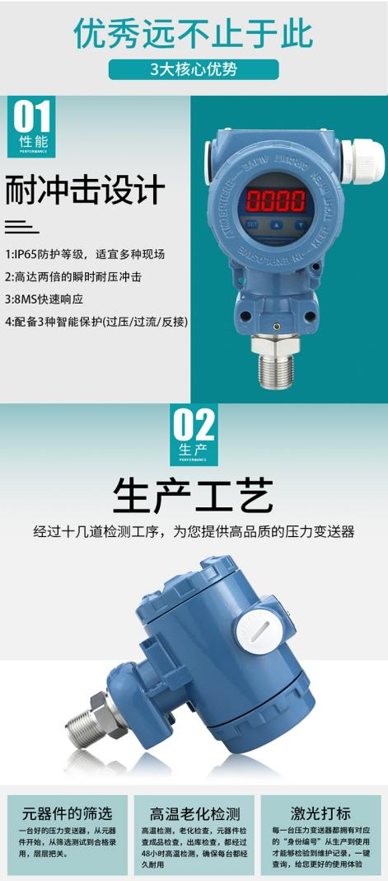
The XY2088 series universal digital display pressure transmitter uses a silicon pressure sensor with a stainless steel isolation film as the signal measurement element, compensating the transmitter for zero points and temperature performance in a wide temperature range using a dedicated IC circuit.
The product is applied to field pressure measurement in industrial processes like petroleum, chemicals, metallurgy, electricity and hydrology.

Product characteristics
    - Scale Range-0.1MPa┅0MPa~0.01MPa┅ 100MPa
    - With the display, display the pressure value in real time
    - Zero point and full range debugging is convenient
    - Reverse polar protection and flow-limiting protection
    - Resistance to lightning strike and pressure resistance to the impact
    - High accuracy, high stability, and high reliability

Application field
    - Industrial process control
    - Hydraulic measurement
    - Pressure measurements for various harsh environments

Appearance structure: (unit: mm)

- Technical parameters

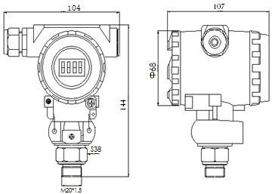

Pressure parameters
Scales | -0.1MPa ┅0MPa~0.01 MPa ┅100MPa
overload | Minimum take of 2 x full range or 110MPa ()
Pressure type | Table pressure, isolation pressure and sealing table pressure
Electrical parameters
Power supply | The 12~32V DC /3.6V battery is powered
Output signal | 4mA ~20mA DC (2-wire system)  0-5V/10V(three-line system)  0-10mA/20mA(three-line system)  RS485modbusRTU protocol (four-line system)  Battery supply band display (no remote transmission signal)  Battery power supply band shows +RS485
Load resistance | ≤（U-12）/0.02Ω
Structural parameters
Shell | Explosion-proof cast aluminum shell
Sensor | 316L stainless steel
Seal ring | Fluorized rubber
Level of protection | IP65
Environmental conditions
Medium applicability | No corrosion free fluids to 316L stainless steel and fluorinated rubber
Compensation temperature | -10℃～80℃
Media temperature | -30℃~80℃ (LCD Display Type: -20℃~80℃)
Storage temperature | -40℃~125℃ (LCD Display Type: -20℃~80℃)
Performance indicators
accuracy | ≤± 0.1%FS(Minimum) | ≤± 0.25%FS(is typical) |  | ≤± 0.5%FS(Maximum)
Zero temperature coefficient | ±0.03%FS/℃ （≤100kPa ） |  | ±0.02%FS/℃ （＞100kPa ）
Full temperature coefficient | ±0.03%FS/℃ （≤100kPa ） |  | ±0.02%FS/℃ （＞100kPa ）
Long-term stability | ± 0.2%FS/ year (max)

  - Electrical connection

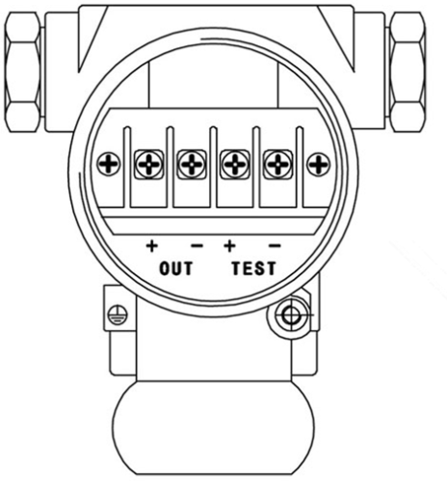
Terminal definition: two-line 4-20mA output
1
2

End | Definition
1（OUT+） | Power supply is positive / 24V+
2（OUT-） | Power supply is negative / 24V-/4-20mA output

Terminal definition: RS485 output
End | Definition
OUT+ | Power supply is positive / 24V+
OUT- | Power supply is negative / 24V-
TEST+ | RS485 output /A
TEST- | RS485 output /B

Terminal definition: 0-5 / 10V three-line output

End | Definition
OUT+ | Power supply is positive / 24V+
OUT- | Power supply negative / 24V-(signal output negative pole is common)
TEST+ | 0-5 / 10V signal output positive pole

Instrument key calibration zero (note: calibration zero, make sure the pressure remains at zero.）

LCD display products
In the measurement state, the instrument is at zero, but not 0, meaning the instrument produces zero drift.Press S calibration zero (to prevent false calibration zero press should be greater than 3 seconds) The instrument displays "-00-", the instrument zero is calibrated.
Digital tube display product
In the measurement state, the instrument is at zero but not 0; the instrument produces zero drift.Press ">" key (to prevent miscalibration zero for greater than 3 seconds) after the instrument displays "0000" with calibration zero.

Type selection guidelines

XY2088 | Series of digital pressure transmitter
 | Scales |  | Measuring range: -0.1MPa┅ 0MPa~0.01 MPa┅ 100MPa
 | [0~X]kPa or MPa |  | X: The actual measurement range
 |  | Codename | Output signal
 |  | S1 | 4mA~20mA DC two-line output
 |  | S2 | 1-5V output
 |  | S3 | 0V-10V three-line output
 |  | F | RS485 (MODBUS RTU protocol)
 |  |  | Codename | Additional features
 |  |  | J01 | ±0.2%FS
 |  |  | J02 | ±0.5%FS
 |  |  | N | There is no display
 |  |  | M3 | 4¹BitLCD number display header  2
 |  |  | M4 | Four-digit LED number header
 |  |  | C3 | G1/2 external threaded pressure interface
 |  |  | C5 | M20× 1.5 External threaded pressure interface
 |  |  | C7 | 50.5KF clamp-type connection
 |  |  | G | Phenotype
 |  |  | A | Expression type
 |  |  | S | Seal table pressure
XY2088X S1J01M4C5G ［0～100］kPa Full specification and model

Type selection tips:

1: Please pay attention to the operating status of pressure detection point and pressure range as complete as possible.Avoid the unnecessary losses caused by the unreasonable use of the product.
2: This product can reach up to 20KHz, in a high-frequency response application, but still needs to communicate with the company about its installation application, so that the product provided can meet the normal needs.
3: Although various protection measures are designed, for extreme applications, such as strong lightning application on site, the power supply should be reliably grounded, and the lightning protection protection device is installed to minimize the probability of product failure.
4: Special application products, can be provided with special design and manufacturing, welcome customers to consult and negotiate.Tel.: 029-88639987

